Lab 1

Section B

Submitted By:

Kent Mark

Submission Date:

1/25/18

**Problem:**

The purpose of this lab was for us to learn how to solve problems with simple arithmetic in C and work with C integer and floating-point math and learn how to use the *“printf”* and *“scanf”* statements.

**Analysis:**

The initial lab problem required information to be entered into the skeleton code that was given. From this the next objective was to duplicate and then rename this skeleton code to “*lab1_2_1.c*” and create a code that takes specific parameters, height and width, from the user and computes the area of a rectangle as seen in “Capture 1”. This code was then renamed to “*lab1_2_2.c*” and modified so that it would take a third dimension from the user, length, and determinate the volume of a rectangular prism and output this value into the terminal as seen in “Capture 2”. The next assignment was littered with intentional errors that had to be rectified with the solution being commented in. Lab problem 4 required that a code be written in order to test various mathematical operations and conversions and then print the various digits to the terminal as seen in “Capture 4”. Finally, lab problem 4 was to design a code that would take numerical input from the user and output a value using the Pythagorean Theorem as seen in “Capture 3”.

**Design:**

For lab problem 1 I simply took the skeleton code that was provided and inserted the necessary information. Then I saved it, opened a duplicate and renamed the duplicate in accordance with lab problem 2. For lab problem 2 I modified the pre-existing code to account for length by defining another variable, which I named “z”, adding a printf statement to take length from the user, adding another scanf statement to take the input for “z”, and finally changing the language of the last printf statement from “Area” to “Volume” while also calling variable “z” and updating the arithmetic to multiply the length, width, and height to get the volume of the prism. The output for this can be found in “Capture 2”. For lab problem 3 I found the errors and commented them into the source code. This can be found under “Source Code #1”. For lab problem 4 the output for some of the operations were erroneous because some operations, for example variables “c” and “d”, involved floats where the decimal was rounded down. For variables “e”, “f”, and “j” the numbers were computed as integers so the decimals were completely disregarded, and for variables “h” and “k” PEMDAS was ignored and the numbers were computed from left to right. To determine the area of a circle I raised 23.567 to the power of 2 using the “pow” function and divided the sum by 4 and multiplied the quotient by 3.14. To convert feet to meters I multiplied 14 by .3048 since 1 foot equals .3048 meters. To convert Fahrenheit to Centigrade I subtracted 32 from 76 and divided the difference by 1.8. Finally for lab problem 5 I took the input for variables “a” and “b” and raised them to power of 2 with the “pow” function and then solved for “c” by embedding the sum of “a + b” into the “sqrt” function. The output can be found in under Capture 3 and the source code can be examined under Source Code #2.

**Testing:**

In order to verify that code for lab problem 4 was functioning I tested the operations with my TI – 83 calculator, and for the conversions I crossed referenced my test values with various online converters. In order to verify that my code for lab problem 5 I entered test values and checked the validity of the answer with my TI – 83 calculator.

**Comments:**

Thanks to this assignment I now have a more firm grasp on using the “printf” statement and the “scanf” statement, as well as the difference between “%d” and “%lf%. One thing that I must always remember to do is carefully and thoroughly scrutinize my work because too much time was wasted in the lab due to error codes and the subsequent minutes spent trying to troubleshoot the error.

**SE 185 Lab 02**

Source Code #2

**- Developed for 185-Rursch by T.Tran and K.Wang**

**- Name:Kent Mark**

**- Section:B**

**- NetID:komark@iastate.edu**

**- Date:1/24/18**

**-----------------------------------------------------------------------------*/**

**/*-----------------------------------------------------------------------------**

**- Includes**

**-----------------------------------------------------------------------------*/**

**#include <stdio.h>**

**#include <math.h>**

**/*-----------------------------------------------------------------------------**

**- Defines**

**-----------------------------------------------------------------------------*/**

**/*-----------------------------------------------------------------------------**

**- Prototypes**

**-----------------------------------------------------------------------------*/**

**/*-----------------------------------------------------------------------------**

**- Implementation**

**-----------------------------------------------------------------------------*/**

**int main()**

**{**

**double a, b, c;**

**double filler;**

**/* Put your code after this line */**

**printf("Enter a value for a: ");**

**scanf("%lf",&a);**

**printf("Enter a value for b: ");**

**scanf("%lf",&b);**

**printf("The numbers you have entered equals %.2f\n",pow(a,2)+pow(b,2));**

**printf("The square root of this number is %.2f",sqrt(pow(a,2)+pow(b,2)));**

**return 0;**

Source Code #1

SE 185 Lab 02

- Developed for 185-Rursch by T.Tran and K.Wang

- Adapted to cpre 185s18 by Swamy Ponpandi

- Name: Kent Mark

- Section: B

- NetID: komark@iastate.edu

- Date: 1/24/18

-----------------------------------------------------------------------------*/

/*-----------------------------------------------------------------------------

- Includes

-----------------------------------------------------------------------------*/

#include <stdio.h>

#include <math.h>

/*-----------------------------------------------------------------------------

- Defines

-----------------------------------------------------------------------------*/

/*-----------------------------------------------------------------------------

- Prototypes

-----------------------------------------------------------------------------*/

/*-----------------------------------------------------------------------------

- Implementation

-----------------------------------------------------------------------------*/

int main()

{

/* Put your code after this line */

int x, y, z;

printf("Enter a width; ");

scanf("%d",&x);

printf("Enter a height: ");

scanf("%d",&y);

printf("Enter a length: ");

scanf("%d",&z);

printf("A %d by %d by %d rectangle's volume is %d\n", x,y,z,x*y*z);

return 0;

}

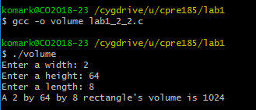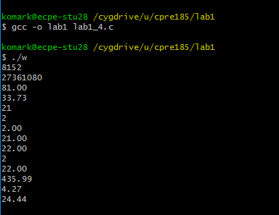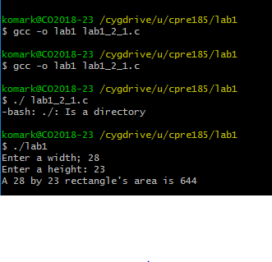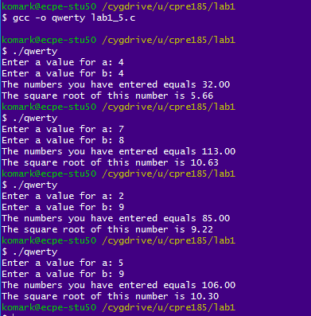

*Capture 4*

*Capture 3*

*Capture 1*

*Capture 2*